T 1.

<!DOCTYPE html>

<html lang="en">

<head>

<title>Shopping List Application</title>

<link rel="stylesheet" href="css/shoppingstyle.css">

<style>

body {

font-family: Arial, sans-serif;

background-color: #f8f8f8;

margin: 0;

padding: 0;

}

.container {

margin: 20px;

}

header {

background-color: #333;

color: white;

padding: 10px;

}

header h1 {

margin: 0;

}

nav ul {

list-style-type: none;

margin: 0;

padding: 0;

}

nav ul li {

display: inline;

margin-right: 10px;

}

.panel {

background-color: #fff;

box-shadow: 0 2px 5px rgba(0, 0, 0, 0.1);

margin-bottom: 20px;

}

.panel-body {

padding: 20px;

}

.form-row {

margin-bottom: 20px;

}

.form-group {

margin-right: 10px;

}

.form-control {

width: 150px;

}

.btn {

background-color: #337ab7;

color: #fff;

padding: 8px 12px;

border: none;

cursor: pointer;

}

.btn:hover {

background-color: #286090;

}

.table-container {

max-width: 800px;

margin: 0 auto;

}

table {

width: 100%;

border-collapse: collapse;

}

th, td {

padding: 10px;

border: 1px solid #ddd;

text-align: left;

}

th {

background-color: #f2f2f2;

}

</style>

</head>

<body>

<div class="container">

<header>

<h1>Shopping List</h1>

<nav>

<ul>

<li class="active"><a href="#">Home</a></li>

<li><a href="#">Page 1</a></li>

<li><a href="#">Page 2</a></li>

<li><a href="#">Page 3</a></li>

</ul>

</nav>

</header>

<div class="panel">

<div class="panel-body">

<div class="form-row">

<div class="form-group">

<label for="itemname">Item Name</label>

<input type="text" class="form-control" name="itemname" id="itemname">

</div>

<div class="form-group">

<label for="qty">Quantity</label>

<select name="quantity" id="qty" class="form-control">

<option value="1">1</option>

<option value="2">2</option>

<option value="3">3</option>

<option value="4">4</option>

<option value="5">5</option>

<option value="6">6</option>

<option value="7">7</option>

<option value="8">8</option>

<option value="9">9</option>

<option value="10">10</option>

</select>

</div>

<div class="form-group">

<label for="priority">Priority</label>

<select name="priority" id="priority" class="form-control">

<option value="low">low</option>

<option value="medium">medium</option>

<option value="high">high</option>

</select>

</div>

</div>

<div class="form-row">

<div class="form-group">

<label for="store">Store Name</label>

<select name="store" id="store" class="form-control">

<option value="Spencers">Spencers</option>

<option value="FUN">FUN</option>

<option value="Whole foods">Whole foods</option>

</select>

</div>

<div class="form-group">

<label for="category">Store Section</label>

<select name="category" id="category" class="form-control">

<option value="Meat">Meat</option>

<option value="Fruits">Fruits</option>

<option value="Vegetables">Vegetable</option>

</select>

</div>

<div class="form-group">

<label for="price">Price</label>

<input type="text" name="price" id="price" class="form-control">

</div>

</div>

<div class="form-row" style="float: right;">

<button onclick="addItem()" class="btn">Add Item</button>

</div>

</div>

</div>

<div class="table-container">

<table>

<thead>

<tr>

<th></th>

<th>Item</th>

<th>Quantity</th>

<th>Store</th>

<th>Section</th>

<th>Price</th>

</tr>

</thead>

<tbody id="list-items"></tbody>

</table>

</div>

</div>

<script>

function loadShoppingList() {

const savedList = localStorage.getItem('shoppingList');

if (savedList) {

document.getElementById('list-items').innerHTML = savedList;

}

}

function saveShoppingList() {

const listHtml = document.getElementById('list-items').innerHTML;

localStorage.setItem('shoppingList', listHtml);

}

function addItem() {

const newItem = document.getElementById('itemname').value.trim();

if (newItem !== '') {

const quantity = document.getElementById('qty').value;

const priority = document.getElementById('priority').value;

const store = document.getElementById('store').value;

const category = document.getElementById('category').value;

const price = document.getElementById('price').value;

const list = document.getElementById('list-items');

const listItem = document.createElement('tr');

listItem.innerHTML = `

<td><input type="checkbox"></td>

<td>${newItem}</td>

<td>${quantity}</td>

<td>${store}</td>

<td>${category}</td>

<td>${price}</td>

`;

list.appendChild(listItem);

document.getElementById('itemname').value = '';

saveShoppingList();

}

}

window.onload = function () {

loadShoppingList();

};

</script>

</body>

</html>

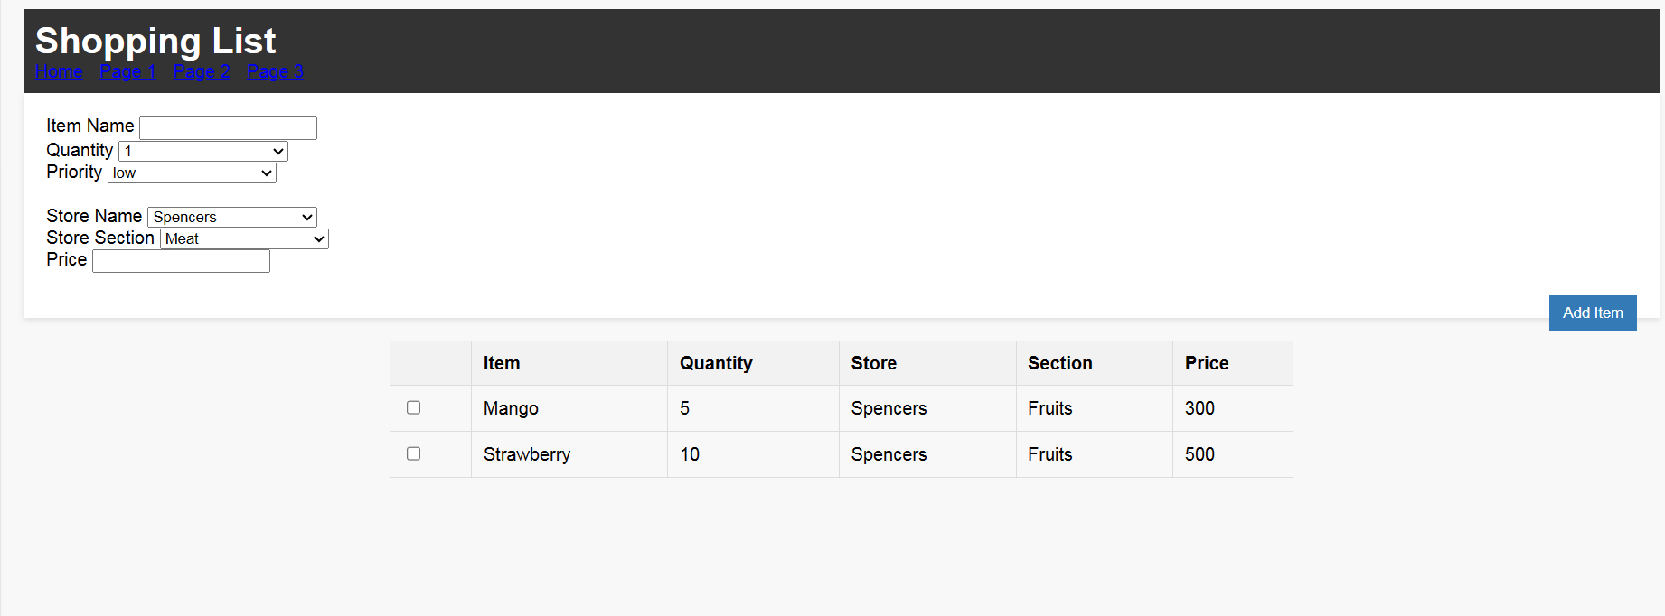

T 2.

<!DOCTYPE html>

<html lang="en">

<head>

<title>Shopping List Application</title>

<link rel="stylesheet" href="css/shoppingstyle.css">

<style>

body {

font-family: Arial, sans-serif;

background-color: #f8f8f8;

margin: 0;

padding: 0;

}

.container {

margin: 20px;

}

header {

background-color: #333;

color: white;

padding: 10px;

}

header h1 {

margin: 0;

}

nav ul {

list-style-type: none;

margin: 0;

padding: 0;

}

nav ul li {

display: inline;

margin-right: 10px;

}

.panel {

background-color: #fff;

box-shadow: 0 2px 5px rgba(0, 0, 0, 0.1);

margin-bottom: 20px;

}

.panel-body {

padding: 20px;

}

.form-row {

margin-bottom: 20px;

}

.form-group {

margin-right: 10px;

}

.form-control {

width: 150px;

}

.btn {

background-color: #337ab7;

color: #fff;

padding: 8px 12px;

border: none;

cursor: pointer;

}

.btn:hover {

background-color: #286090;

}

.table-container {

max-width: 800px;

margin: 0 auto;

}

table {

width: 100%;

border-collapse: collapse;

}

th, td {

padding: 10px;

border: 1px solid #ddd;

text-align: left;

}

th {

background-color: #f2f2f2;

}

</style>

</head>

<body>

<div class="container">

<header>

<h1>Shopping List</h1>

<nav>

<ul>

<li class="active"><a href="#">Home</a></li>

<li><a href="#">Page 1</a></li>

<li><a href="#">Page 2</a></li>

<li><a href="#">Page 3</a></li>

</ul>

</nav>

</header>

<div class="panel">

<div class="panel-body">

<div class="form-row">

<div class="form-group">

<label for="itemname">Item Name</label>

<input type="text" class="form-control" name="itemname" id="itemname">

</div>

<div class="form-group">

<label for="qty">Quantity</label>

<select name="quantity" id="qty" class="form-control">

<option value="1">1</option>

<option value="2">2</option>

<option value="3">3</option>

<option value="4">4</option>

<option value="5">5</option>

<option value="6">6</option>

<option value="7">7</option>

<option value="8">8</option>

<option value="9">9</option>

<option value="10">10</option>

</select>

</div>

<div class="form-group">

<label for="priority">Priority</label>

<select name="priority" id="priority" class="form-control">

<option value="low">low</option>

<option value="medium">medium</option>

<option value="high">high</option>

</select>

</div>

</div>

<div class="form-row">

<div class="form-group">

<label for="store">Store Name</label>

<select name="store" id="store" class="form-control">

<option value="Spencers">Spencers</option>

<option value="FUN">FUN</option>

<option value="Whole foods">Whole foods</option>

</select>

</div>

<div class="form-group">

<label for="category">Store Section</label>

<select name="category" id="category" class="form-control">

<option value="Meat">Meat</option>

<option value="Fruits">Fruits</option>

<option value="Vegetables">Vegetable</option>

</select>

</div>

<div class="form-group">

<label for="price">Price</label>

<input type="text" name="price" id="price" class="form-control">

</div>

</div>

<div class="form-row" style="float: right;">

<button onclick="addItem()" class="btn">Add Item</button>

</div>

</div>

</div>

<div class="table-container">

<table>

<thead>

<tr>

<th></th>

<th>Item</th>

<th>Quantity</th>

<th>Store</th>

<th>Section</th>

<th>Price</th>

</tr>

</thead>

<tbody id="list-items"></tbody>

</table>

</div>

</div>

<p>This page has been accessed <span id="accessCount">0</span> times.</p>

<script>

function updateAccessCount() {

var accessCount = parseInt(localStorage.getItem("accessCount")) || 0;

accessCount++;

localStorage.setItem("accessCount", accessCount);

document.getElementById("accessCount").textContent = accessCount;

}

updateAccessCount();

function loadShoppingList() {

const savedList = localStorage.getItem('shoppingList');

if (savedList) {

document.getElementById('list-items').innerHTML = savedList;

}

}

function saveShoppingList() {

const listHtml = document.getElementById('list-items').innerHTML;

localStorage.setItem('shoppingList', listHtml);

}

function addItem() {

const newItem = document.getElementById('itemname').value.trim();

if (newItem !== '') {

const quantity = document.getElementById('qty').value;

const priority = document.getElementById('priority').value;

const store = document.getElementById('store').value;

const category = document.getElementById('category').value;

const price = document.getElementById('price').value;

const list = document.getElementById('list-items');

const listItem = document.createElement('tr');

listItem.innerHTML = `

<td><input type="checkbox"></td>

<td>${newItem}</td>

<td>${quantity}</td>

<td>${store}</td>

<td>${category}</td>

<td>${price}</td>

`;

list.appendChild(listItem);

document.getElementById('itemname').value = '';

saveShoppingList();

}

}

window.onload = function () {

loadShoppingList();

};

</script>

</body>

</html>

